Temasek Polytechnic
School of Informatics and IT

Diploma in Information Technology (IT)

Software Development Life Cycle (SDLC)

Project Particulars

Tutor | Mr Qi Yutao
Class | P01
Project Title | Delonix Regia Hotel Management System

Project Team’s Particulars

Matric Number | Student Name
1303140F | Jaelyn Lim Hui Wen
1303084F | Loh Shi Jia, Serene
1304174D | Leong Min En
1306932C | Reyner Leong

Table of Contents
1. Introduction 3
2. Objectives of the Project 4
3. Scope of the Project 4
4. Distribution of Workload 8
5. Constraints 9
6. Resources 9
7. Product Positioning in the Market/Company 9
8. Approach and Methodology of the Project 11

Jaelyn Lim Hui Wen’s Software Development Life Cycle (SDLC)
Software Development Lifecycle (SDLC) is the process which consist of a series of steps or phases that provide a model for the development and lifecycle management for the development, maintenance, alternation or enhancement of an application or a piece of software. It is exercised during a software development to improve the quality of a software and the overall department process.
A typical SDLC model consists of the following six phases:
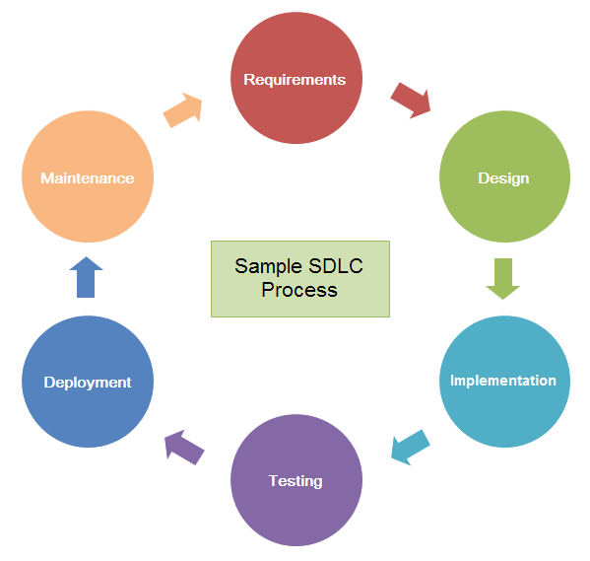
- Planning & Requirement Analysis
It is the most important phase in software development and is usually performed by senior members of the team, who are more skilled and experienced. They are required to gather, analyse, validates information from the clients, the sales department, market surveys and domain experts in the industry to determine and specify the requirements needed. It helps to create a requirement specification which will serves as a guideline for the next phase and a scope document where the basic approach of the project will be determined and documented. There will also be a planning for the quality assurance requirements and identifications of risks associated with the project.
- Designing
In this phase, the system and software design specification will be prepared based on the requirements specification in the planning and requirement analysis phase. The hardware and system requirements and the overall system architecture will be specified and defined in the specification. It will then be reviewed by all the key stakeholders for approval before the next phase can be executed.
- Implementation
The implementation phase is the longest phase of the SDLC. The developers will start this phase by dividing the work which are stated in the system and software design specification into different units and working on implementing the design specified into executable programming language code.
- Testing
During the testing phase, the software developed after the implementation phase will go through different testing activities such as unit testing, integration testing, system testing and acceptance testing to detect errors in the software and ensure that the software meets the needs addressed and gathered during the planning and requirement analysis phase. If there are any defects in the software, it will be reported, tracked, fixed and retested until the software reaches the quality standards defined in the requirement specification.
- Deployment
After successful testing and approval for release of the software, it will be ready to be deployed and released formally in the appropriate market or to the clients for their use in the deployment phase.
- Maintenance
The maintenance phase is a phase whereby it helps to solves actual problems which clients faced occasionally after they have actually started to use the developed software. It is also a phase whereby improvements are made to meet the new requirements requested by the clients.

There are various software development process models available and the following are 3 examples of it:
- Incremental Model
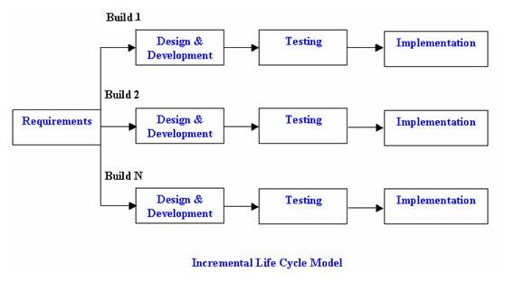
Incremental model is a method of software development where the whole software requirements are split up into various standalone module so that the cycle can be easily managed with smaller modules. Each module include the design, implementation and testing phases. The modules are interrelated to one another but a module is able to exist on its own without the other module or functionality. It is similar to having multiple waterfall cycle taking place in an iterative manner. During the first module, a working version of a software will be produced and the software will be used in the subsequent modules where more functions will be added in. This process will continue until the completed software system which meets the requirements is achieved.

Advantages | Disadvantages
- Initial product delivery is faster  - Lower initial delivery cost  - Generates working software quickly and early during the software life cycle  - More flexible – less costly to change scope and requirements  - Easier to test and debug during a smaller iteration  - Customer can respond to feature and review the product  - Easier to manage risk | - Requires good planning, analysis and design  - Requires a clear and complete definition of the whole system before it can be broken down and built incrementally  - Each phase of an iteration is rigid and do not overlap each other  - Resulting cost may exceed the cost of the organization  - Additional functionality added to the product may cause problems related to the system architecture

- Agile Model
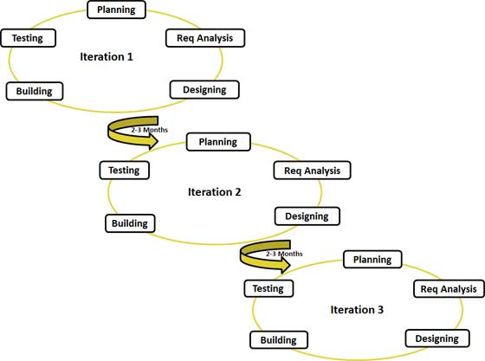
Agile model is a type of incremental model whereby a software is developed in incremental and rapid cycles while focusing on the process adaptability and customer satisfaction. The software is broken up into small incremental builds, with each builds, that are provided in iterations, building on previous functionality. Each iteration involves various areas like planning, requirements analysis, design, coding, unit testing and acceptance testing. This ensures that each builds are thoroughly test and that the software quality is maintained.

Advantages | Disadvantages
- Little and no planning required  - Easy to manage  - Give flexibility to developers  - Minimal rules, documentation easily employed  - Customer satisfaction by rapid, continuous delivery of useful software.  - People and interactions are emphasized rather than process and tools  - Resource requirements are minimum  - Working software is delivered frequently (weeks rather than months)  - Close, daily cooperation between business people and developers  - Continuous attention to technical excellence and good design  - Regular adaptation to changing circumstances  - Even late changes in requirements are welcomed | - Not suitable for handling complex dependencies.  - Lack of emphasis on necessary designing and documentation  - More risk of sustainability, maintainability and extensibility  - Depends heavily on customer interaction, so if customer is not clear, the project can easily get taken off track  - Very high individual dependency since there is minimum documentation generated  - No place for newbie programmers, unless combined with experienced resources

- Rapid Application Development (RAD) Model
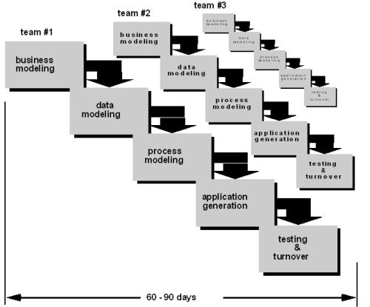
Rapid Application Development (RAD) model is a type of incremental software process model that focus on using minimal planning in favour of rapid prototyping. A prototype is a working model that is functionally equivalent to a component of the product. In a RAD model, the components are developed in parallel prototypes as if they were mini projects and are integrated to make the complete product for faster product delivery which allows the clients to provide feedback with, regarding the delivery and their requirements.
There are five phases in a Rapid Application Development (RAD) model:
  - Business Modelling
The business model for the software under development is designed in terms of flow of information and the distribution of information between various business functions. A business analysis is also performed to find the necessary information for business.
  - Data Modelling
Information gathered in the previous phase is reviewed and analysed to define data objects that are needed for the business.

  - Process Modelling
The data objects defined in the previous phase will then be converted to establish the business information flow needed to achieve some specific business objectives. Process descriptions are identified and created for adding, deleting, retrieving or modifying of data objects. Any changes or enhancements to the data objects are also defined in this phase.
  - Application Generation
Process and data models are converted into codes by using automation tools and the actual system is built.
  - Testing and Turnover
The prototype produced in the previous phase will be independently tested during every iteration to reduce the overall testing time in the model.

Advantages | Disadvantages
- Flexible and adaptable to changes  - Reduced development time  - Increases reusability of components  - Quick initial reviews occur  - Encourages customer feedback  - Integration from very beginning solves a lot of integration issues.  - Realizes an overall reduction in project risk  - Productivity with fewer people in short time | - Depends on strong team and individual performances for identifying business requirements.  - Only system that can be modularized can be built using RAD  - Requires highly skilled developers/designers  - High dependency on modelling skills  - Inapplicable to cheaper projects as cost of modelling and automated code generation is very high  - Higher management complexity  - Requires user involvement throughout the life cycle

Leong Min En’s Software Development Life Cycle (SDLC)
Software Development Life Cycle is basically a series of steps and stages the provide model for the development and lifecycle management of either an application or software.
Incremental Model
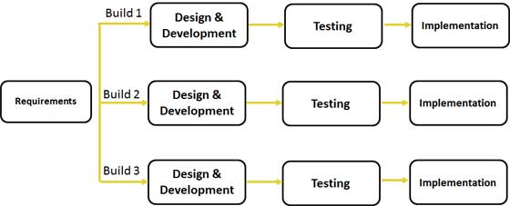
The incremental build model is a method of software development where the model is designed, implemented and tested a little more is added every single time until the product is finished. It involves both development and maintenance. The product is considered finish when it fulfils all of the requirement that is stated.
The product will then be separated into different components, which are designed and built separately. Each component will then be delivered to client when it is completed. This allows partial utilisation of the product and it will take lesser development time. This model help to calm the stressful effect when a completely new system is being introduce all at once.
The advantage of using this model is that it is able to generate working software quickly and early during the software life cycle. It is more flexible compare to other model and it cost lower when there is a need to change the scope and the requirement. It is easy to test and debug the software during the smaller iteration and also easier to manage risk because risky element are mostly identified and handled during the iteration.

RAD Model
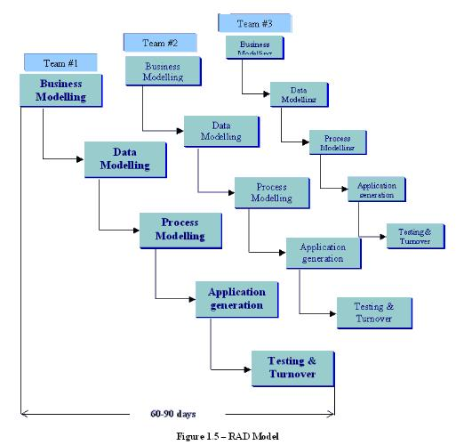
Rapid application development (RAD) is a concept that products can be developed faster and with high quality through gathering requirements and information through workshops or focus group. It also set a tightly paces schedule that defers design improvements to the next product version. This can efficiently and quickly give the customer something to see and use so that they are able to provide feedback regarding the delivery and their requirements.

The advantage of the RAD model is that it is able to reduce the development time for the software, it also help to increase the reusability of components. It also encourages customer to give feedback to the software so that the company is able to make good improvement for their customers.

Spiral model
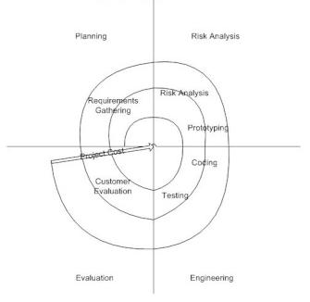
The spiral model of development combines the features of the prototyping model and waterfall model. The spiral model is normally used in large, expensive and complicated projects.
The steps in the spiral model are:
- The new system requirement are needed to be as detailed as possible. It usually involves interviewing a number of users which are representing the external and internal user and other aspects of the existing system.
- A drafted design will be created for the new system.
- The first prototype of the new system will be constructed from the drafted design.
- The second prototype will be evolved by evaluating the first prototype then defining the requirements again followed by planning and the designing of the second prototype and lastly constructing and testing out the second prototype.
- From the customer’s option, the entire project can be aborted if they think the risk is too big.
- The existing prototype is evaluated in the same manner as was the previous prototype
- The preceding steps are iterated until the customer is satisfied that the refined prototype represents the final product desired.
- The final system is constructed, based on the refined prototype.
- The final system is thoroughly evaluated and tested. Routine maintenance is carried out on a regular basis to prevent large-scale failures and to minimize downtime.
The advantages of spiral model is that it is good for large and mission-critical projects. Strong approval and documentation control. If there are any additional functionality it can be added at a later date.

Reyner Leong’s Software Development Life Cycle (SDLC)
What is SDLC
SDLC stands for Software Development Life Cycle. A Software Development Life Cycle is essentially a series of steps, or phases, that provide a model for the development and lifecycle management of an application or piece of software. The methodology within the SDLC process can vary across industries and organizations, but standards such as ISO/IEC 12207 represent processes that establish a lifecycle for software, and provide a mode for the development, acquisition, and configuration of software systems.

Model 1

Iterative Model design

Model 1 Explanation
Like other SDLC models, Iterative and incremental development has some specific applications in the software industry. This model is most often used in the following scenarios:
- Requirements of the complete system are clearly defined and understood.
- Major requirements must be defined; however, some functionalities or requested enhancements may evolve with time.
- There is a time to the market constraint.
- A new technology is being used and is being learnt by the development team while working on the project.
- Resources with needed skill set are not available and are planned to be used on contract basis for specific iterations.
- There are some high risk features and goals which may change in the future.
Model 1 Pros and Cons
Pros | Cons
- Some working functionality can be developed quickly and early in the life cycle.  - Results are obtained early and periodically.  - Parallel development can be planned.  - Progress can be measured.  - Less costly to change the scope/requirements.  - Testing and debugging during smaller iteration is easy.  - Risks are identified and resolved during iteration; and each iteration is an easily managed milestone.  - Easier to manage risk - High risk part is done first.  - With every increment operational product is delivered.  - Issues, challenges & risks identified from each increment can be utilized/applied to the next increment.  - Risk analysis is better.  - It supports changing requirements.  - Initial Operating time is less.  - Better suited for large and mission-critical projects.  - During life cycle software is produced early which facilitates customer evaluation and feedback. | - More resources may be required.  - Although cost of change is lesser but it is not very suitable for changing requirements.  - More management attention is required.  - System architecture or design issues may arise because not all requirements are gathered in the beginning of the entire life cycle.  - Defining increments may require definition of the complete system.  - Not suitable for smaller projects.  - Management complexity is more.  - End of project may not be known which is a risk.  - Highly skilled resources are required for risk analysis.  - Project.s progress is highly dependent upon the risk analysis phase.

Model 2

V- Model design
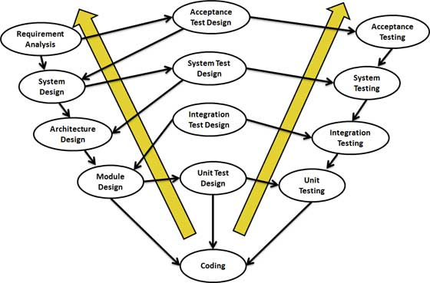
Model 2 Explanation
V- Model application is almost same as waterfall model, as both the models are of sequential type. Requirements have to be very clear before the project starts, because it is usually expensive to go back and make changes. This model is used in the medical development field, as it is strictly disciplined domain. Following are the suitable scenarios to use V-Model:
- Requirements are well defined, clearly documented and fixed.
- Product definition is stable.
- Technology is not dynamic and is well understood by the project team.
- There are no ambiguous or undefined requirements.
- The project is short.
Model 2 Pros and Cons
Pros | Cons
- This is a highly disciplined model and Phases are completed one at a time.  - Works well for smaller projects where requirements are very well understood.  - Simple and easy to understand and use.  - Easy to manage due to the rigidity of the model . each phase has specific deliverables and a review process. | - High risk and uncertainty.  - Not a good model for complex and object-oriented projects.  - Poor model for long and ongoing projects.  - Not suitable for the projects where requirements are at a moderate to high risk of changing.  - Once an application is in the testing stage, it is difficult to go back and change a functionality  - No working software is produced until late during the life cycle.

Model 3

Spiral Model design
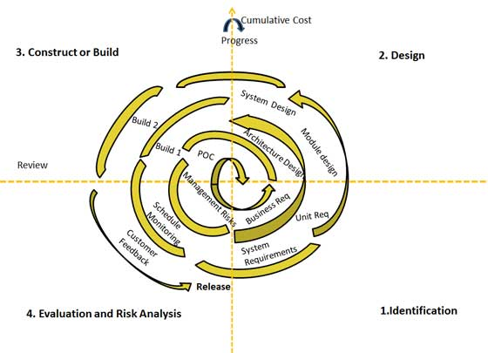

Model 3 Explanation
Spiral Model is very widely used in the software industry as it is in synch with the natural development process of any product i.e. learning with maturity and also involves minimum risk for the customer as well as the development firms. Following are the typical uses of Spiral model:
- When costs there is a budget constraint and risk evaluation is important.
- For medium to high-risk projects.
- Long-term project commitment because of potential changes to economic priorities as the requirements change with time.
- Customer is not sure of their requirements which is usually the case.
- Requirements are complex and need evaluation to get clarity.
- New product line which should be released in phases to get enough customer feedback.
- Significant changes are expected in the product during the development cycle.
Model 3 Pros and Cons
Pros | Cons
- Changing requirements can be accommodated.  - Allows for extensive use of prototypes  - Requirements can be captured more accurately.  - Users see the system early.  - Development can be divided into smaller parts and more risky parts can be developed earlier which helps better risk management. | - Management is more complex.  - End of project may not be known early.  - Not suitable for small or low risk projects and could be expensive for small projects.  - Process is complex  - Spiral may go indefinitely.  - Large number of intermediate stages requires excessive documentation.

Loh Shi Jia, Serene’s Software Development Life Cycle (SDLC)
A short description to explain the meaning of Software Development Life Cycle (SDLC).

Software Development Life Cycle, SDLC for short, is a well-defined, structured sequence of stages in software engineering to develop the intended software product. It is a framework defining tasks performed at each step in the software development process. SDLC is a process used by software industry to design, develop and test high quality softwares.
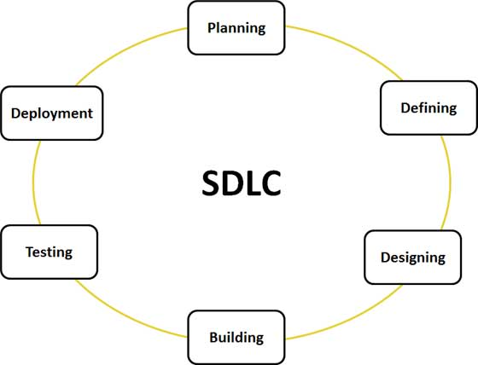

Figure 1: A graphical representation of the various stages of typical a Software Development life cycle

In general, an SDLC methodology follows the following steps:
- The existing system is evaluated. Deficiencies are identified. This can be done by interviewing users of the system and consulting with support personnel.
- The new system requirements are defined. In particular, the deficiencies in the existing system must be addressed with specific proposals for improvement.
- The proposed system is designed. Plans are laid out concerning the physical construction, hardware, operating systems, programming, communications, and security issues.
- The new system is developed. The new components and programs must be obtained and installed. Users of the system must be trained in its use, and all aspects of performance must be tested. If necessary, adjustments must be made at this stage.
- The system is put into use. This can be done in various ways. The new system can phased in, according to application or location, and the old system gradually replaced. In some cases, it may be more cost-effective to shut down the old system and implement the new system all at once.
- Once the new system is up and running for a while, it should be exhaustively evaluated. Maintenance must be kept up rigorously at all times. Users of the system should be kept up-to-date concerning the latest modifications and procedures.

